INTERNET OF THINGS
PRE-WORK ON
SMART SECURITY ALARM SYSTEM
-SANJANA SR
1MS19IS408
5TH SEM
C SECTION

DATE OF SUBMISSION:26/12/2020 SIGNATURE OF FACULTY

MARKS OBTAINED:

Contents

1. Introduction

2. Components Required

3. Block diagram

4. Circuit Diagram

5. Flowchart

6. Advantages and Disadvantages

7. Applications

8. Conclusion

Abstract

The objective of this project is to develop a modern security system, in which the laser security uses to ON the buzzer in the case of entry intruders during the absence of the owner. Laser door alarm is based on the interruption of Laser beam. The laser pointer is used as the source of light beam. If somebody tries to break the laser path, then an alarm will be generated in a few seconds also send message via Bluetooth module to smart phone . Laser transmitter is a laser pointer readily available. This is powered with 5 volt DC supply and fixed on one side of the door frame.

- Introduction

Security is a most important factor today. Technology develops day by day in the world. The crime gang also improves their technology toper form their operation. So technology of security should be modern with time to protect the crime works. We decide to make a security project as our project. In this project we have used laser light to cover a large area. We know laser light goes through long distance without scattering effect. It’s also visible only at source and incident point, otherwise invisible. These two properties help us to build up a modern security system, which may name as “laser security”. When any person or object crossover the laser line the security alarm will ringing and also the focus light will “on” to focus the entrance of unauthorized person. We can make a security boundary of single laser light by using mirror at every corner for reflection. Our project provides complete information on the topic "Laser Security Alarm System" and maximum efforts have been taken to make the project more comprehensive and lucid to understand. Our project covers a variety of sub topics like its working, setup, uses in life and different aspects of Laser Security Alarm System

- Components Required

Hardware

Hardware is the physical parts or components of the system. In this project work, we’ve used some hardware such as

- Arduino Uno
- LDR
- Bluetooth module
- Laser diode
- 9V Battery
- L.E.D
- Piezo Buzzer
- Breadboard
- Some Jumper Wires
- An USB Cable
- A Computer

- Microcontroller ARDUINO:

Arduino Uno is open source hardware and microcontroller board which is based on ATmega328P Processor. It has 14 digital input/output and 6 analog input pins and operates at 5 volts and 16 MHz quartz crystal frequency. It has 32 KB flash memory, 2 Kb SRAM and 1 KB EEPROM

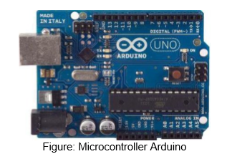

- LDR (Light Dependent Resistor):

A light dependent resistor (LDR) or a photo resistor is a device whose resistivity is a function of the incident electromagnetic radiation. Hence, they are light sensitive devices. They are also called as photo conductors, photo conductive cells or simply photocells. They are made up of semiconductor materials having high resistance. It works on the principle of photo conductivity. Photo conductivity is an optical phenomenon in which the materials conductivity is increased when light is absorbed by the material. LDR’s are light dependent devices whose resistance is decreased when light falls on them and that is increased in the dark. When a light dependent resistor is kept in dark, its resistance is very high. This resistance is called as dark resistance.
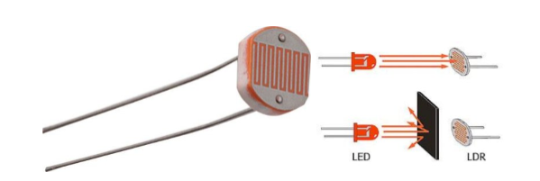

- Laser Diode (LD)

A laser diode or LD also known as injection laser diode or ILD. It is an electrically pumped semiconductor laser in which the active laser medium is formed by a p-n junction of a semiconductor diode similar to that found in a light-emitting diode Here we use 5volts LD. Therefore, they can operate using small battery power supplies.
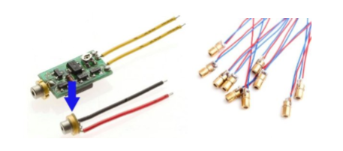

- Block diagram

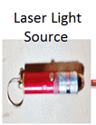

LDR

Arduino Uno




No object present, No signal given to the Arduino



LDR

Arduino Uno



Object present , signal given to the Arduino

Working

When any person or object crossover the laser line the security alarm will ringing and also send message via Bluetooth module to smart phone .
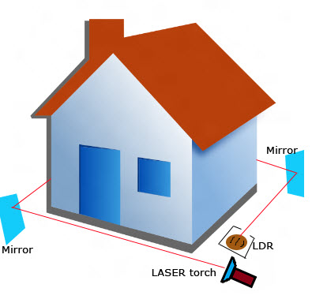

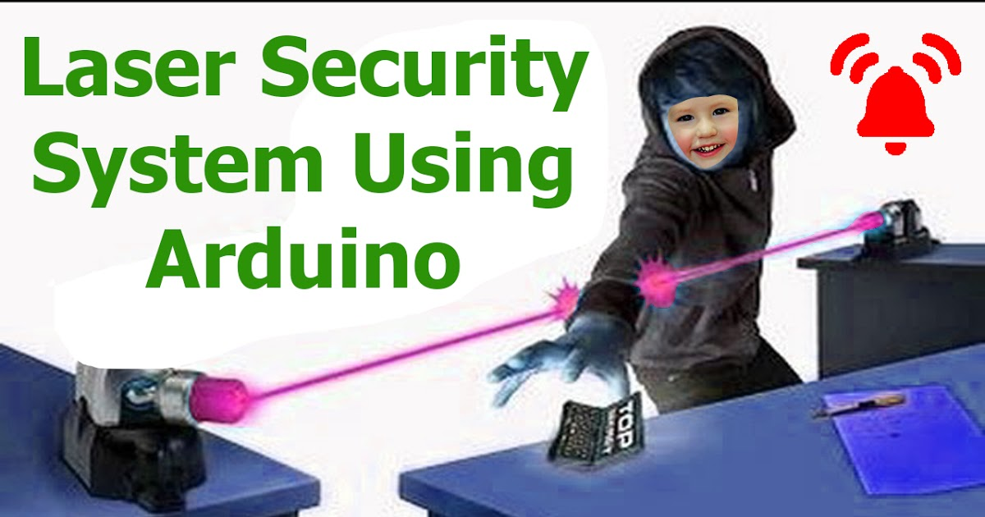

4. Circuit Diagram

Aurdino uno
Bluetooth module
HC-05
Laser diode

LDR

Arduino With Bluetooth

Aurdino UNO

VCC RX

GND TX

TX RX VCC GND
Bluetooth module

Here we have connected the Bluetooth module with ARDUINO UNO. Here TX of arduino is connected with Bluetooth RX and RX of arduino is connected with TX of Bluetooth module. Respectively VCC and GND also connected from Arduino module.
Breadboard:———–Arduino Pins:———Breadboard
Buzzer——————– Pin9————————Gnd
Laser———————– 5v————————–Gnd
Resistor—————— A0—————————Gnd,Photocell
Photocell——————-5v————————-Resistor
Led———————-Pin6,Pin7

5. Flowchart

Begin

Initialize the variable and ports

Set mode of operation of ports

Main loop

Data available from photo sensor

NO
Alarm ON

YES

Read the analog from LDR
Bluetooth ON

Whole system is secured

6. Advantages and Disadvantages

Advantages

- The given system is handy and portable, and thus can be easily carried from one place to another.
- The circuitry is not that complicated and thus can be easily troubleshooted.
- The given system sets off a powerful buzzer, and it is effective as any other alarm system available in the market.

Disadvantages

- The given alarm system determines the presence of the intruder only, and does not determine how many persons are in there actually.

7. Applications

This type of motion sensing alarm system can be easily employable for security purposes at banks, various offices and even for sensitive establishments such as for military. We can easily set up this system for household purposes.

8. Conclusion

- The focus of this project is to develop a security system using the concept of Laser security

- An electronic circuit is designed that start alarming when anyone interrupt the Laser

- The Smart Security systems have many advantages. They are simple to install and can be used successfully inside or outside a home.

References

- https://www.modulight.com/applications-security/
- http://coral-home.over-blog.com/article-how-does-gsm-alarm-system-work-78700141.html
- http://circuitdigest.com/electronic-circuits/laser-security-alarm-circuit-diagram
- http://www.hkvstar.com/company-news/what-is-gsm-alarm-system.html
- http://alarmsim.com/index.html
- http://www.instructables.com/id/Protect-Your-Home-with-Laserbeams/
- http://www.asecurelife.com/reasons-to-install-home-security-system/
- http://www.rxpaper.com/
- https://en.wikipedia.org/wiki/Arduino
- https://www.arduino.cc/en/Guide/Introduction
- https://www.adafruit.com/product/2637

